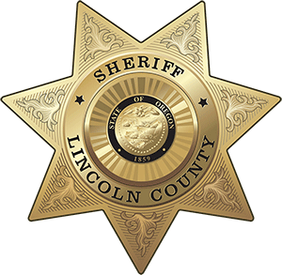OFFICE OF THE SHERIFF

# Sheriff Curtis L. Landers

225 W. Olive Street

Newport, Oregon 97365

(541) 265-4277

Fax (541) 265-4926

## 

## **MEDIA RELEASE**

**FOR IMMEDIATE RELEASE**

Date: November 16, 2021

Contact: Virginia “Jenny” Demaris, Emergency Manager

(541) 265-4199

[vdemaris@co.lincoln.or.us](mailto:vdemaris@co.lincoln.or.us)

**NWS Holds Winter Seasonal Outlook for Lincoln, Tillamook, and Clatsop Counties**

[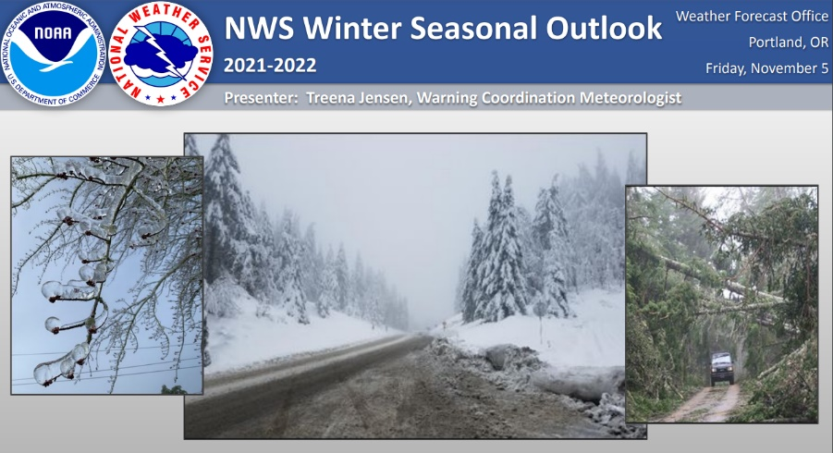](https://www.co.lincoln.or.us/sites/default/files/fileattachments/emergency_management/page/4631/lincoln_clatsop_nws_2021_22_winter_seasonal_outlook_-_public.pdf)During the first week of November the National Weather Service (NWS) Portland held a winter weather briefing for public safety officials in Lincoln, Tillamook, and Clatsop counties.

The full presentation can be viewed [here](https://www.co.lincoln.or.us/sites/default/files/fileattachments/emergency_management/page/4631/lincoln_clatsop_nws_2021_22_winter_seasonal_outlook_-_public.pdf).

**Highlights from 2021**

* Many areas throughout Oregon experienced the driest March-May period on record.
* Many locations also broke their all-time high temperature records during the week of June 26-30.

**Winter Weather Outlook**

* Higher chances for cooler and wetter than normal conditions for the Pacific Northwest in the upcoming winter months.
* Higher than normal wave heights are expected along the west coast this winter.
* November 2021 through January 2022 are expected to be wetter than normal for the time of year.
* February 2022 through April 2022 are expected to be wetter than normal with cooler temperatures than normal for the time of year.

**NWS Resources from the Briefing**

* [NWS Weather Information](https://www.weather.gov/pqr/)
* [NWS Winter Weather Safety Resources](https://www.weather.gov/wrn/winter_safety)
* [Seguridad Meteorológica](https://www.weather.gov/wrn/spanish) (Weather Safety)
* [NWS Weather Safety Information for Deaf and Hard of Hearing](https://www.weather.gov/wrn/dhh-safety)

**Flood Resources for Individuals and Businesses**

**Reminders from Oregon Division of Financial Regulation (DFR):**

* Flood damage - A typical homeowners policy does not cover flood damage; you would need a specific rider or National Flood Insurance policy. For more information on flood insurance visit the National Flood Insurance Program or [DFR – Flood Insurance](https://dfr.oregon.gov/insure/home/storm/Pages/flood.aspx).
* Comprehensive coverage on a typical auto insurance policy will cover damage to your car caused by a flood.
* Contact your insurance agent or insurance company to review your coverage and make a claim.
* If you have questions or concerns after speaking with your insurance company, call the consumer advocates at DFR for free help. 888-87-4894 (toll free.)
* **If your home or car is damaged by flood:**
  + Make safety the top priority when surveying storm damage, avoid downed power lines, and watch your step walking around storm debris.
  + Save all receipts you obtain from hiring professionals or purchasing supplies to make temporary repairs.
  + Record the highest water line on your car and DO NOT attempt to start a flooded vehicle until inspected by a professional.

**Suggested actions:**

* Stay informed:
  + Monitor [National Weather Service](https://www.weather.gov/pqr/) information and updates ([website](https://www.weather.gov/pqr/) or [Facebook](https://www.facebook.com/NWSPortland))
  + [NWS Watches/Warnings](https://alerts.weather.gov/cap/wwaatmget.php?x=ORC041) for Lincoln County
  + Check [current conditions](https://www.co.lincoln.or.us/emergencymanagement/page/current-conditions-alerts-and-warnings) page on County EM website
  + Check specific [river levels](https://www.co.lincoln.or.us/emergencymanagement/page/hazards-flooding-and-river-levels) on County EM Website
* Expect full to overflowing streams and creeks possibly in a very short time frame
* Allow for extra driving time, check [ODOT Trip Check](https://www.tripcheck.com/Pages/Road-Conditions?curRegion=0&mainNav=RoadConditions) or 511 before you go
* Check on vulnerable neighbors, friends and family that may be affected
* Periodically check your property, stream banks, buildings for effects from the storm event
* Before flooding occurs:
  + Use [sandbags](https://www.co.lincoln.or.us/sites/default/files/fileattachments/emergency_management/page/4631/lincoln_co_self-serve_public_sandbag_station.pdf) to reroute water away from structures
  + Check your [Lincoln Alerts](http://www.co.lincoln.or.us/alerts) profile if you want to receive alerts specifically for the Alsea, Salmon, Siletz, Yachats, and Yaquina rivers [www.co.lincoln.or.us/alerts](http://www.co.lincoln.or.us/alerts)
    - Those with addresses in the FEMA flood plains are pre grouped to receive flood notification messages based on their location.

**Additional Resources:**

* [Current Conditions (Alerts and Warnings)](https://www.co.lincoln.or.us/emergencymanagement/page/current-conditions-alerts-and-warnings)
* [Information Guide: Flooding](https://www.co.lincoln.or.us/sites/default/files/fileattachments/emergency_management/page/4631/information_guide_-_flooding.pdf) – What to do before, during, and after a flood
* [Financial and Business Preparedness – Wildfire Readiness 2021](https://www.youtube.com/watch?v=c1AZ72f5hQc&list=PLBRoB7Cay1NJsaP6Gnc2xcVliKu73T0Gv&index=3)
  + Although this video was part of the 2021 Wildfire Readiness series, this financial preparedness information is applicable for all hazards.
* [Flooding and River Levels](https://www.co.lincoln.or.us/emergencymanagement/page/hazards-flooding-and-river-levels)
  + Current River Levels
  + Live Flood Dashboard (NOAA)
  + Weather Forecasts
  + Preparedness Info
  + Self-Serve Sandbag Station

[](https://www.floodsmart.gov/)

**Flood Insurance:**

* Property Owners:
  + Flood insurance is for more than just those living in the flood plain. This coverage may also protect homes and businesses in other events like tsunamis. Property owners may be eligible to update their insurance. Flood insurance coverage has a 30 day waiting period before the coverage is active. Review the [National Flood Insurance Program](https://www.floodsmart.gov/) page for more information.
* Renters:
  + All renters should have renters insurance to protect your belongings or if you accidentally cause damage. Check with your insurance agent to see if flood insurance is part of your policy. Your landlord may also have flood insurance for the property.

**###**

**Respectfully submitted,**

**Virginia "Jenny" Demaris**Emergency Manager  
Lincoln County Sheriff's Office - Emergency Management  
225 W. Olive St., Newport, Oregon 97365  
[vdemaris@co.lincoln.or.us](mailto:vdemaris@co.lincoln.or.us) , (541) 265-4199 Office